**Aim: Program to blink Arduino onboard LED and To interface external LED with Arduino and write a program to turn ON LED for 1 sec after every 2 seconds.**

**THEORY:**

**ARDUINO:**

It is an open-source electronics platform based on easy-to-use hardware and software. Arduino boards are able to read inputs - light on a sensor, a finger on a button, or a Twitter message - and turn it into an output - activating a motor, turning on an LED, publishing something online. You can tell your board what to do by sending a set of instructions to the microcontroller on the board. To do so you use the Arduino programming language (based on Wiring), and the Arduino Software (IDE), based on Processing.

**ONBOARD LED:**

There are 4 LED on Arduino of different color from which 3 are located nearby and one is little far away.

1. Power LED (Green):

It is a basic LED which power ON when the device is connected to a power supply (USB or Adapter). It is green in color and shows that arduino is powered ON.

1. Status LED (Orange):

It is a built-in LED connected to digital pin 13. When the pin is HIGH value, the LED is on, when the pin is LOW, it's off. It is Orange in color. It is also used to make basic LED blinking

1. Serial Communication LED's (Orange):

Serial communication LED's are basically communication LED which are powered on when the board sends or receives any data from computer through USB cable.

o TX: When arduino sends data to PC ( eg. sending information ) o RX: When arduino receives data from PC ( eg. downloading program )

**LED:**

In the simplest terms, a light-emitting diode (LED) is a semiconductor device that emits light when an electric current is passed through it. Light is produced when the particles that carry the current (known as electrons and holes) combine together within the semiconductor material. Since light is generated within the solid semiconductor material, LEDs are described as solid-state devices.

**RESISTOR:**

A resistor is a passive two-terminal electrical component that implements electrical resistance as a circuit element. In electronic circuits, resistors are used to reduce current flow, adjust signal levels, to divide voltages, bias active elements, and terminate transmission lines, among other uses.

High-power resistors that can dissipate many watts of electrical power as heat may be used as part of motor controls, in power distribution systems, or as test loads for generators. Fixed resistors have resistances that only change slightly with temperature, time or operating voltage. Variable resistors can be used to adjust circuit elements (such as a volume control or a lamp dimmer), or as sensing devices for heat, light, humidity, force, or chemical activity.

**CIRCUIT DIAGRAM:**

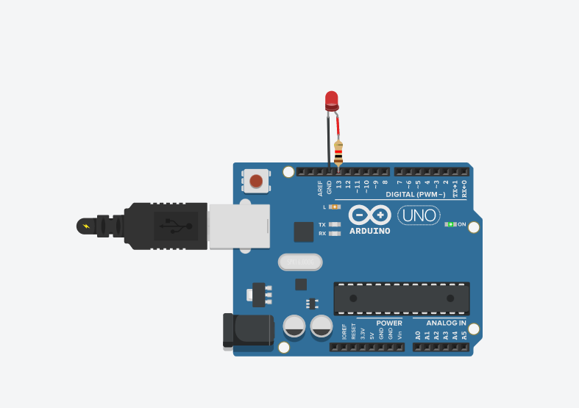

**SOURCE CODE:**

void setup() {

pinMode(13, OUTPUT);

}

void loop() {

digitalWrite(13, HIGH);

delay(1000);

digitalWrite(13, LOW);

delay(2000);

}

**CONCLUSION:**

Successfully programmed an Arduino board to blink onboard LED and to interfaced an external LED with Arduino